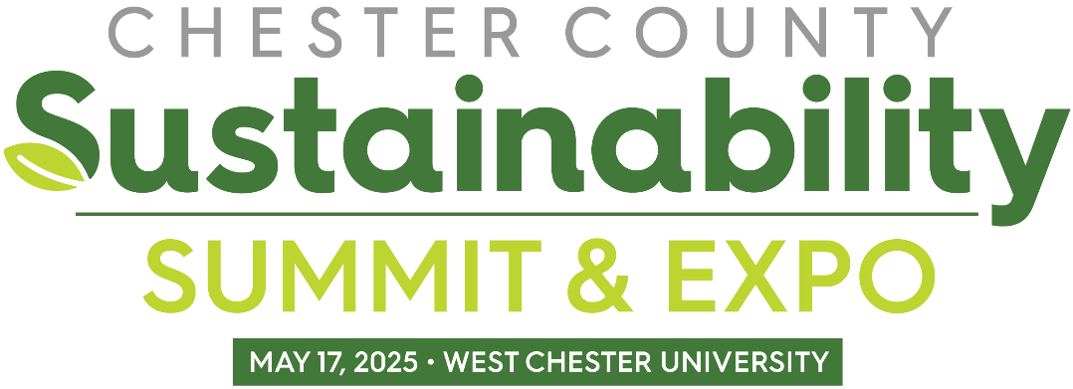

**Partner Toolkit**

10:00 a.m. – 2:00 p.m. at West Chester University

The 2025 Sustainability Summit and Expo on Saturday, May 17, will be the premier sustainability event in Chester County! This event will provide educational opportunities for the public to receive practical, clear and trustworthy information on topics like going solar, reducing their energy usage, and maintaining more sustainable landscapes. The event will take place at [West Chester University's Sciences and Engineering Center](https://maps.app.goo.gl/r7V1S4SFuHEhMafb9), 155 University Ave., West Chester, PA 19383.

We invite you to join us in sharing this event on social media and elsewhere!

You can find/tag the Chester County Planning Commission (CCPC) on Facebook, LinkedIn, X (Twitter), and Instagram:

* Facebook: [@ccplanning](https://www.facebook.com/ccplanning)
* LinkedIn: “[Chester County Planning Commission](https://www.linkedin.com/company/chester-county-planning-commission/)”
* X: [@ChescoPlanning](https://twitter.com/ChescoPlanning)
* Instagram: [@ChescoPlanning](https://www.instagram.com/chescoplanning/)

*Please see the following sample language for sharing the 2025 Sustainability Summit on your platforms.*

**Facebook**

Do you want to learn how to become more sustainable? Join @ccplanning for the 2025 Sustainability Summit & Expo on Saturday, 5/17, (10 a.m. – 2 p.m.). This event will be your one-stop-shop to hear from experts, chat with neighbors, meet local contractors, and learn about ways to get involved in your community. Topics highlighted will include solar power, heat pumps, energy efficiency, sustainable landscaping, and more. You won’t want to miss it! Learn more and register: <https://chescoplanning.org/Events/SustainabilitySummit-2025.cfm>

**LinkedIn**

Chester County Planning Commission’s 2025 Sustainability Summit and Expo will be the premier sustainability event in Chester County! All are invited to come out on Saturday, May 17, from 10 a.m. to 2 p.m. to hear from sustainability experts, chat with experienced neighbors, meet local contractors, and find ways to get involved in your community. It’s an event you won’t want to miss. To learn more and register, visit https://chescoplanning.org/Events/SustainabilitySummit-2025.cfm

**X**

Don’t miss @ChescoPlanning’s 2025 Sustainability Summit on 5/17! It’s a great way to connect with others and learn how to become more sustainable. Learn more & register: <https://chescoplanning.org/Events/SustainabilitySummit-2025.cfm>

**Instagram**

You’re invited to Chester County’s 2025 Sustainability Summit & Expo on May 17! Join @ChescoPlanning for a jam-packed day filled with discussions and examples about all things sustainable. You can hear from experts, chat with neighbors, meet local contractors, and learn about ways to get involved in your community. You won’t want to miss it! Visit chescoplanning.org to register.

**Newsletter/Other Communications**

Chester County Planning Commission’s 2025 Sustainability Summit and Expo will be the premier sustainability event in Chester County! You’re invited to come out on Saturday, May 17, from 10 a.m. to 2 p.m. to:

* Hear from experts on how to implement sustainable energy and landscaping projects at your home or business.
* Chat with neighbors who have experience with things like geothermal heating, going solar, ecological landscaping, composting, electric vehicles, and more.
* Meet local contractors who can help you with these projects.
* Learn about ways to get involved in your community.

To learn more and register, visit <https://chescoplanning.org/Events/SustainabilitySummit-2025.cfm>.

**Image**

